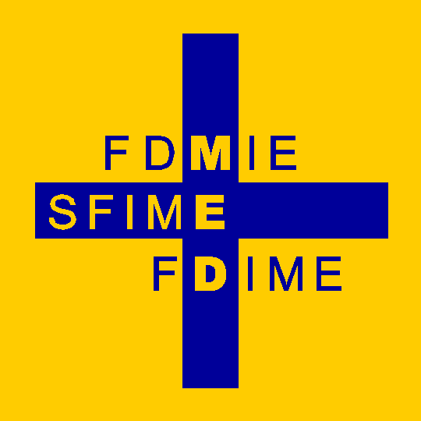 | Fondation pour le Développement de la Médecine Interne en Europe  Stiftung für die Förderung der Inneren Medizin in Europa  Foundation for the Development of Internal Medicine in Europe
FDIME ANNOUNCES ‘INTERNAL MEDICINE RESEARCH GRANTS’ in 2025

The Foundation for the Development of Internal Medicine in Europe (FDIME) announces the availability of grants for EFIM Young Internists. The funding is intended for research projects dedicated to polymorbidity and other common conditions in Internal Medicine.
Up to 17,500 Euros is available, to be awarded for a maximum study period of 1 year.
Deadline for Receipt of Applications: 30 June 2025

Application Criteria / Eligibility

Young Internists/Researchers who are interested to apply must meet the following criteria:-

- Be an Internist as defined by EFIM (refer to: http://www.efim.org/en/what-is-internal-medicine-913 )

- Be < 38 years of age.

- Be a member of one of the National Societies of Internal Medicine affiliated to EFIM, for at least one year before applying.

- Be able to submit a relevant project proposal. The project can cover translational medicine, basic or clinical research.

Important Information

- Grants will be awarded for a period of up to one year of study, and are not renewable.

- The objective of the Grant is to promote exchanges between European researchers enabling them to undertake research.

- The purpose of the grant is to provide financial support for the applicant’s lifestyle during the period of research. It is expected that the applicant will be occupied full time with his/her specified research study and not receiving any salary. The applicant is required to submit a budget plan itemizing expected living costs / travel expenses for the intended study period. The Grant funding is not intended to be used for organizing the research itself.

- The applicant must inform FDIME of any additional sources of funding that are available for the intended research study period.

For application contact:
sereni.daniel@gmail.com or loic.guillevin@orange.fr or sejeanbart@yahoo.com

Essential Documents Required to Accompany the Research Grant Application

The following information and documentation must be provided:-

1. Your up-to-date Curriculum Vitae including your Home and Work Address,
telephone number, and e-mail address + a recent photograph of yourself.

2. A Letter of Recommendation / Support from a Board Member of your National Society of Internal Medicine (as proof of membership of your Society).

3. Title and Summary of the Project (max 500 words in English).

4. Full details of the Project Proposal – in English

5. The name of the Laboratory or Department of Medicine where the project will be undertaken. If a dual location is intended, state the details of both locations.
Note: Projects should start in 2025, but after 30.09.2025

6. A letter from the Chief of Laboratory or Department of Medicine, certifying that the project will be carried out in their laboratory/clinical department. Include the name and email address of the research study Supervisor, and expected start date and duration of study.
If a dual location is intended, a letter from both institutes is required.

7. Budget Plan estimating monthly living costs/expenses in the host city/country where the research will be carried out, including a total for the period of intended study.

Note: For clinical research projects and research on animal models, the opinion of an Ethics Committee should be obtained.

Additional Information

The FDIME Research Grant will be transferred to The Recipient by bank transfer in two stages:-
Half immediately before starting the project, and half at mid-term.
An interim report will be required mid-term before the second installment can be paid.
After receiving the Research Grant, The Recipient is responsible for paying any tax/duties that may be required in their home country.

At the end of the period of research, The Recipient has the obligation to submit an article (review or original article) in the European Journal of Internal Medicine (EJIM) to report on at least a part of the research that has been undertaken. Publication(s) of the original results of the research, can be published in any journal. The grant provided by FDIME must be included in an Acknowledgement at the end of the article and in any presentation of the study project results.

The Research Grant Selection Board Chaired by Professor Loïc Guillevin, President of the Scientific Council of FDIME, Paris will assess all applications.
The decision is of the Research Grant Selection Board is irrevocable. The reasons for any adverse decision made by the Grant Selection Board will not be discussed with the applicant.

