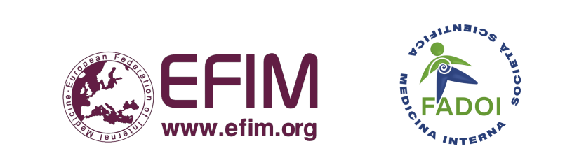
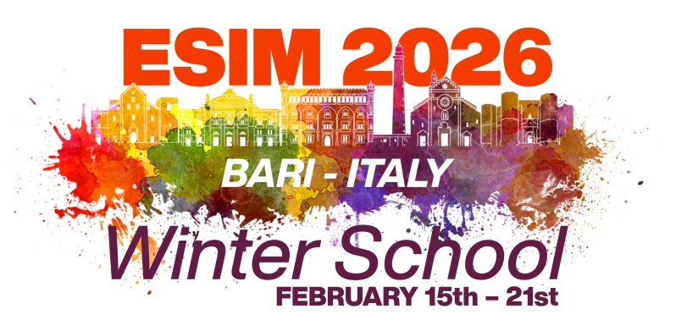 | European School  of Internal Medicine:  Winter School in Puglia,  Italy, 2026

Date: October 2025

16-20 February 2026  Venue: Masseria Agrituristica Lama San Giorgio, Rutigliano, Puglia, Italy | Venue: Masseria Agrituristica Lama San Giorgio, Rutigliano, Puglia, Italy  Course dates: 16-20th February 2026 (Monday to Friday)  Arrival: Sunday, 15th February  Departure: Saturday, 21st February
 | Dear Friends,  It is our great honour to host the Winter School of the European School of Internal Medicine 2026 in Rutigliano, Puglia, Italy.  As with previous ESIM courses, we need help from all of the EFIM National Societies in proposing speakers, and in advertising the School to potential residents. The principle of applying through your Society is that it enables you to select young internists who will most benefit from this educational experience. In order to plan effectively we would like to know your intentions at this stage:  1. Potential Speakers:  Complete Form A – please return by 10th November 2025  We would like to hear from speakers who are interested in participating at ESIM. As you are aware, the travel expenses of speakers will be the responsibility of their National Society, but ESIM will pay for up to 2-3 nights’ accommodation and all meals during their stay. Kindly consult the preliminary programme (via website) to aid guide your suggestions.  2. Sending Residents:  Complete Form B – please return by 10th November 2025  We also need to know how many residents your National Society is hoping to send to ESIM. At the Winter School we aim to accept up to 50-55 residents from EFIM member countries, with a maximum of 2-3 per country. Ideally, ESIM participants should be under the age of 36 and in the second half of their training in Internal Medicine. They must be fluent in English.  The registration fee will be 1250 Euros per person which will include the following: accommodation for 6 nights (please note that rooms may be double, triple, or even quadruple, depending on the number of participants; therefore, participants must be willing to share a room with others of the same gender), all meals, school facilities, internet access, educational materials and various social activities. The sponsoring National Society will also be responsible for paying the travel costs of each resident. The venue is accessible by airport transfer from Bari (detailed instruction will be given to participants). You will receive the registration form when we receive your completed Form B (Intention to Send Residents). We kindly ask that the names of residents be submitted by 10 November 2025 to: esim.winter.italy@fadoi.org  The provisional topics of the programme and preliminary timetable are available at the website: https://www.fadoi.org/esim-winter-school-2026/  On behalf of the School, I thank you for your continued support and I look forward to hearing from you soon.  With best regards,  Prof. Francesco Dentali  Director of ESIM Winter School in Puglia (Italy)
  ESIM Director:
  Prof. Francesco Dentali
Co-Directors and Organizing Committee:

E-mail: esim.winter.italy@fadoi.org

Website: https://www.fadoi.org/esim-winter-school-2026/

Enclosed: Form A (Speakers); Form B (Intention to Send Residents)

