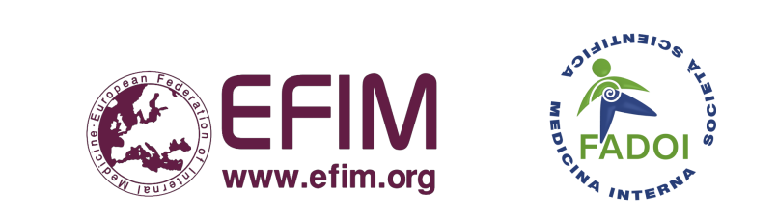
 | European School  of Internal Medicine:  Winter School in Puglia,  Italy, 2026

16-20 February 2026  Venue: Masseria Agrituristica Lama San Giorgio, Rutigliano, Puglia, Italy | EUROPEAN SCHOOL OF INTERNAL MEDICINE  Venue for the Winter School:  Masseria Agrituristica Lama San Giorgio,  Rutigliano, Puglia, Italy  Dates: Sunday 15th to Saturday 21st February 2026  Course dates: Monday 16th to Friday 20th February 2026  FORM A: SPEAKER PROPOSAL  Please refer to the preliminary program (website) for guidance and return by 10th November 2025  SPECIFIC DIETARY REQUIREMENTS:  - Allergies (please specify: ……………………………………...…..)  - Intolerances (please specify: …………………………….………..)  - Vegetarian  - Vegan  - Gluten-free  - Specific diet (please specify: ……………….……………………..)  INTEREST IN PARTICIPATING IN THE FOLLOWING EVENTS:  - Guided Tour of the Castellana Caves  - Visit to Centro di Selezione Equestre di Galeone and Trulli of Alberobello  - Winery with wine tasting
  Name of the person completing this form:
  E-mail address:
  I propose:
  (Name of possible Speaker)*
  Topic Proposed and/or
  Lecture Title
  *Contact Details of the Speaker you have proposed:
  Title (Prof/Dr)
  and Name:
  Specialty:
  His/Her E-mail:
  Office Tel.:
  Mobile Tel.:
  (please indicate)
ESIM Director:
Prof. Francesco Dentali

Co-Directors and Organizing Committee:

E-mail: esim.winter.italy@fadoi.org

Website: https://www.fadoi.org/esim-winter-school-2026/

Please, complete and return this form as soon as possible, at the latest by 10th November 2025 to:
ESIM WS in Puglia Director: Prof. Francesco Dentali
E-mail: esim.winter.italy@fadoi.org

