

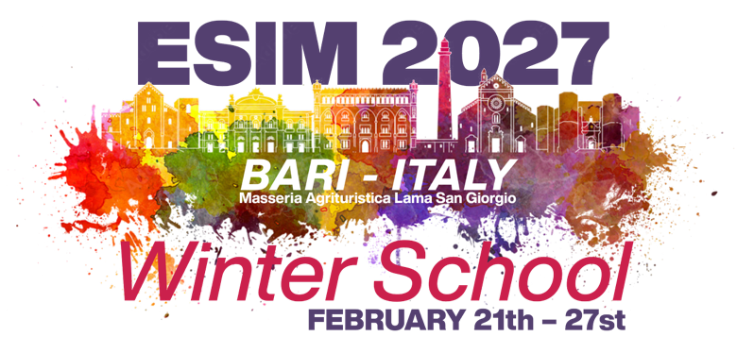 | European School  of Internal Medicine:  Winter School in Puglia,  Italy, 2027

21-27 February 2027  Venue: Masseria Agrituristica Lama San Giorgio, Rutigliano, Puglia, Italy | EUROPEAN SCHOOL OF INTERNAL MEDICINE  Venue for the Winter School:  Masseria Agrituristica Lama San Giorgio,  Rutigliano, Puglia, Italy  Dates: Sunday 21th to Saturday 27st February 2027  Course dates: Monday 22th to Friday 26th February 2027  FORM B: INTENTION TO SEND RESIDENTS  Please return by 15th November 2026  Eligibility for ESIM: Young Internists should have a good command of the English language, be in the second half of their training in Internal Medicine, and, ideally, under the age of 36 years.  The academic programme and interaction will be in English and will include: lectures, clinical case presentations, workshops and clinico-pathological sessions.  We can accept 2-3 Young Internists from each EFIM member country (depending on the number of countries wishing to send delegates). National Societies are kindly requested to advertise the availability of the ESIM Winter Course and to organise and receive applications from potential candidates in order to select the residents who will attend, sponsored by your National Society.  For each participant, we need to know the following information:  NAME AND SURNAME  GENDER M or F (to organize accomodation). Please note that rooms may be double, triple, or even quadruple, depending on the number of participants; therefore, participants must be willing to share a room with others of the same gender.  SPECIFIC DIETARY REQUIREMENTS:  - Allergies (please specify: ……………………………………...…..)  - Intolerances (please specify: …………………………….………..)  - Vegetarian  - Vegan  - Gluten-free  - Specific diet (please specify: ……………….……………………..)
  Name of your National Society
  Name of person completing this form
  Your E-mail Address
  (for follow up contact)
  Your Telephone Number
  Please State the Number of Residents that your National Society is hoping to send to ESIM Winter School 2026
ESIM Director:
Prof. Francesco Dentali

Co-Directors and Organizing Committee:

E-mail: esim.winter.italy@fadoi.org

Please, complete and return this form as soon as possible, at the latest by 15th November 2026 to:
ESIM WS in Puglia Director: Prof. Francesco Dentali
E-mail: esim.winter.italy@fadoi.org

