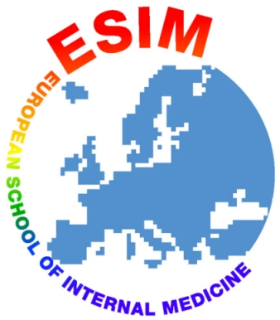 |  | EUROPEAN SCHOOL OF INTERNAL MEDICINE  Summer School in El Escorial, Madrid, Spain– June 2022  Venue: Real Centro Universitario El Escorial-María Cristina  Sunday 12th June to Saturday 18th June 2022  FORM A  SPEAKER PROPOSAL  *Contact Details of the Speaker you have proposed:-  Please Complete and Return This Form by 30 March 2022  to: Dr. Javier Moreno - ESIM DIrector  e-mail address: javimorenomdr@hotmail.com
  Name of the person completing this form:
  E-mail address:
  I propose the Name of:
  (as a possible Speaker)*
  Topic Proposed and/or
  Lecture Title
  Title (Prof/Dr)
  and Name:
  Specialty:
  His/Her E-mail:
  Office Tel.:
  Mobile/Handy Tel.:
  (please, indicate)
  Postal Address (if known):
  Country:
Website:
www.esim2022.com
12 - 18 June 2022
Venue:
Real Centro Universitario El Escorial-María Cristina
El Escorial, Madrid. Spain
ESIM Director:
Dr. Javier Moreno Díaz
Co-Directors:
Dr. Gemma Ortiz Llauradó
Dr. Asunción Gonzálvez Gasch
Dr. Cristina Macia Rodriguez
Dr. Daniel Martín Iglesias
Dr. Reinold Gans
ESIM 2022 Secretariat:
Grupo Pacífico
Email:
summerschool-semi@pacifico-meetings.com

Supported by:
Spanish Society of Internal Medicine

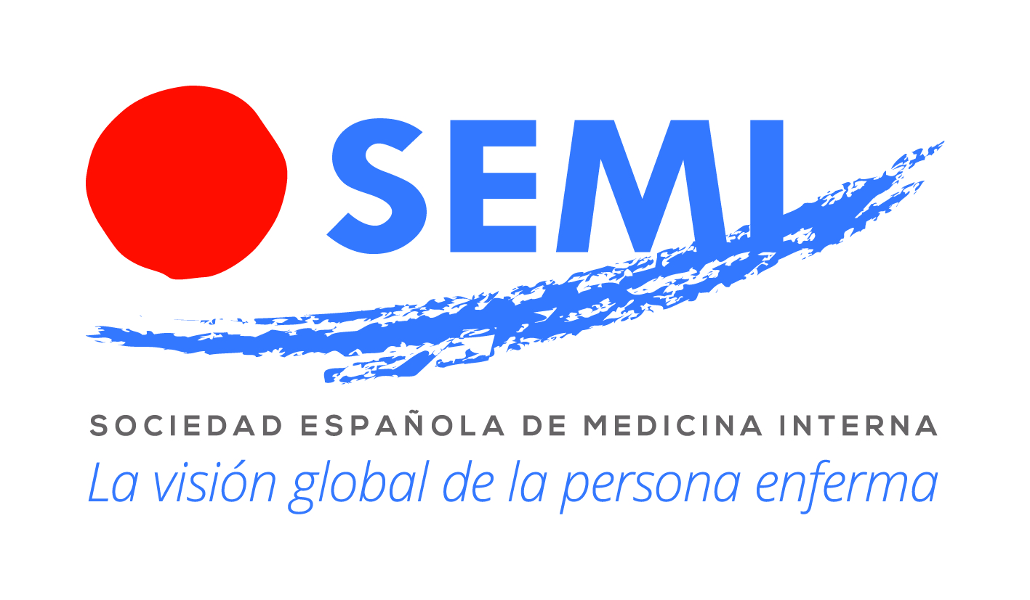

www.fesemi.org

