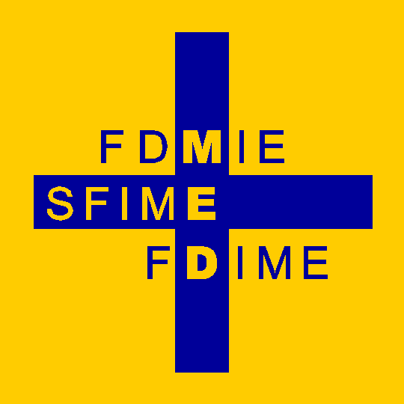 | Fondation pour le Développement de la Médecine Interne en Europe  Stiftung für die Förderung der Inneren Medizin in Europa  Foundation for the Development of Internal Medicine in Europe

FDIME RESEARCH GRANT AWARDS

Terms and Conditions of Acceptance of the FDIME Research Grant Award

The Foundation for the Development of Internal Medicine in Europe (FDIME) agrees to provide Grant funding to the Award Recipient of the FDIME Research Grant. The total amount will be specified on the Phase 1 Agreement that will be prepared indicating the Grant Recipient’s Name.

FDIME agrees the following Terms and Conditions

To pay the Award Recipient by Bank Transfer in two instalments.

The first instalment will be paid to the Award Recipient at the start of the Research Project. It is acknowledged that the Award Recipient may require funds to purchase travel tickets and/or pay deposit for accommodation in the host country before arrival. To facilitate any advanced expenses incurred, FDIME will endeavour to pay the first instalment in the month stated by the Award Recipient on the Bank Details form.

The second instalment will be paid to the Award Recipient half way through the Research Project, and after FDIME has received an Interim Report outlining the present status of the research activities including what has been achieved in Phase 1, and what is planned for Phase 2 and completion of the Project.

The Bank Transfer of the first instalment will be made to the Award Recipient who has signed ‘PHASE 1 Agreement’. ‘PHASE 1 Agreement’ will subsequently be signed and authorised by:-

- The President of FDIME (Prof Daniel Sereni)
And
- The Treasurer of FDIME (Dr Imad M-M Hatem)

The Financial Award to the Award Recipient is not valid unless ‘PHASE 1 Agreement’ (and subsequently PHASE 2 Agreement submitted half-way through the Project) is signed and dated by all three parties.

The Bank Transfer of the second instalment will subsequently be made to the Award Recipient who will sign ‘PHASE 2 Agreement’ after Phase 1 of the project has been completed.

FDIME bears no responsibility for monies paid to the Award Recipient once the payment has reached the Recipient’s bank account. The recipient is responsible for paying any tax/duties that may be required in their home country and any other jurisdiction.

Fondation pour le Développement de la Médecine Interne en Europe
Stiftung für die Förderung der Inneren Medizin in Europa
Foundation for the Development of Internal Medicine in Europe

The Award Recipient agrees to the following Terms and Conditions

1. The Research Project Study identified by the Award Recipient and approved by FDIME will be undertaken at the Research Institute that has been stated by the Grant Recipient as the location of the study project.

2. The Funding provided by FDIME will be used solely for the purpose of supporting living and travel expenses whilst the Award Recipient undertakes his/her specified research study project.

3. The Funding received from FDIME will be held securely in the Award Recipient’s bank account until it is required for the purpose intended. It is understood that the Award Recipient is solely responsible for paying any tax or duties that are required from them by the Government in their home country or host country, and that FDIME bears no responsibility for the Award Recipient’s fiscal situation.

4. On completion of the Research Project, the Award Recipient is required to submit an article (Abstract or full article) to the European Journal of Internal Medicine (EJIM) to report on at least a part of the research that has been undertaken. Publication(s) of the original results of the research may be published in any journal. The results of the Research Project are also required to be presented at the next European Congress of Internal Medicine (ECIM) either as an Oral or a Poster Presentation. The author may also present the results of the project at his/her National Congress or at any other Internal Medicine Meeting. Furthermore the Author should provide FDIME with an interim progress report and a final article published within two years of the end of the work and mentioning the funding of the FDIME.
FDIME aims to publish the Final Report on the FDIME website either in the full format, or in a summary format, and/or with a link to the publication on the relevant Journal website, with the consent and approval of the Author(s).

5. The Research Grant provided by the FDIME must be included as an Acknowledgement in any published article or presentation where the results of the study carried out by the Award Recipient are reported.

Note: The Award Recipient will be invited to attend an FDIME Research Grant Award Ceremony at the European Congress of Internal Medicine (ECIM) in 2027, and is expected to make his/her own arrangements to attend this event.

Contact Details:
- Dr Jan Willem Elte, FDIME Secretary General. Email: jwfelte@gmail.com
- Prof Daniel Sereni, FDIME President, Email: sereni.daniel@gmail.com

